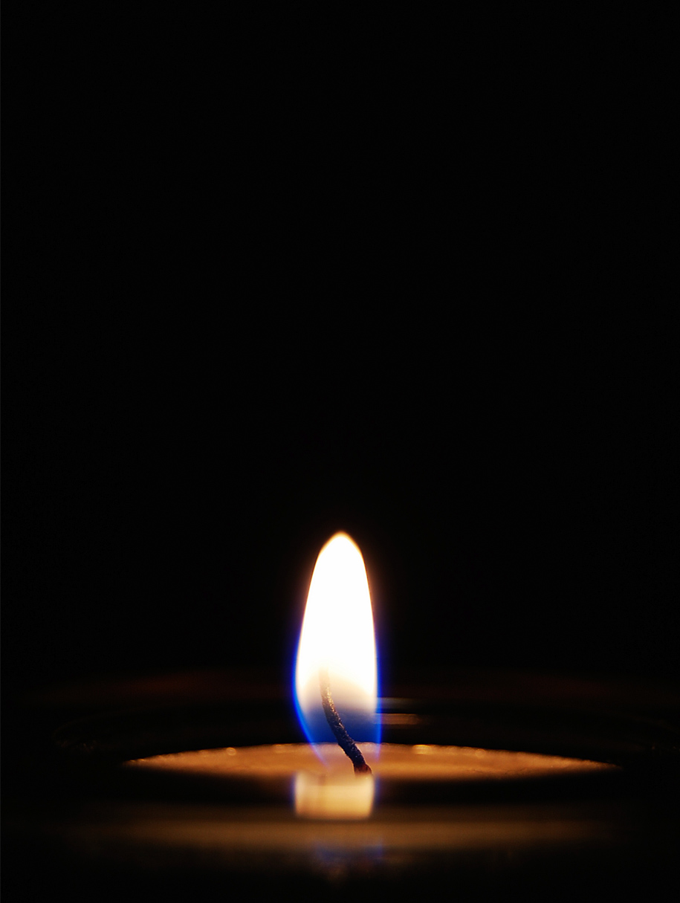
In memory of
Avraham and Sarah
Schwartz
Dedicated by their son
Yitzchok Schwartz

